# Results RepGrid and Identity Study

## Prediction of stressful situations

### Hypothesis:

**H1:** We can predict the most stressful situations for every user by knowing their core identity constructs.

**H2:** We can predict the least stressful situations for every user by knowing their more outer identity constructs.

### Methodology:

* Calculated the 3 situations with highest stress rating per user (or more if they had the same rating)
* Calculated the 3 situations with the lowest stress rating per user (or more if they had the same rating)
* Checked how many of the core identity constructs are in the list of highest rated situations and vice versa for the outer constructs and lowest situations
* Excluded users that had the same rating for the lowest in the top situations and and the highest in the low situations (N=13)
* Calculated the percentage of overlap

### Results:

We were able to confirm both hypotheses

* With the core identity constructs we could predict 85,25% of the most stressful situations.
* With the outer identity constructs we could predict 89,5% of the least stressful situations.

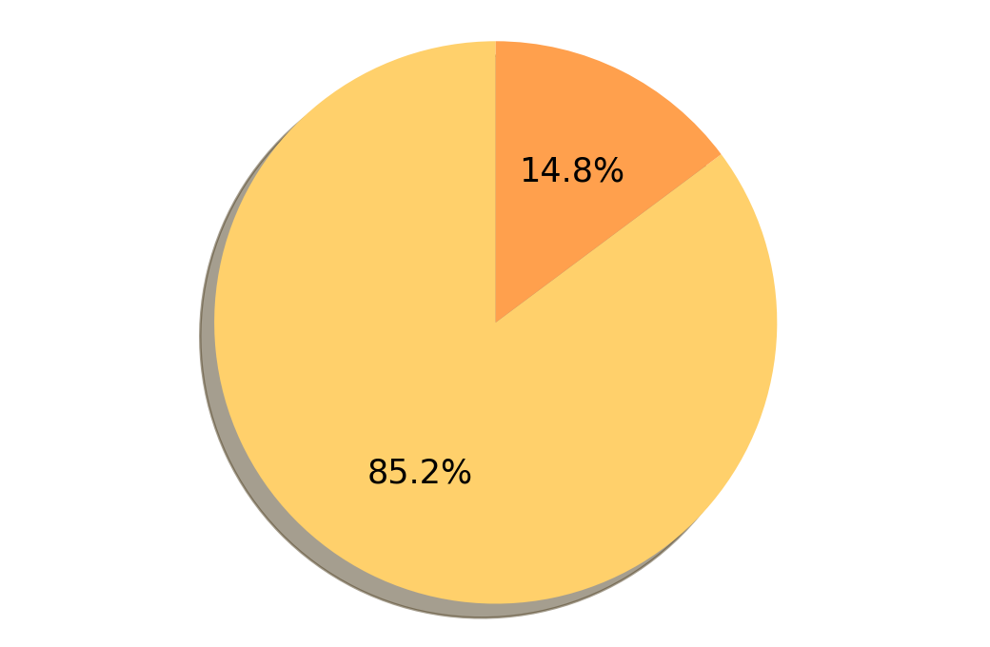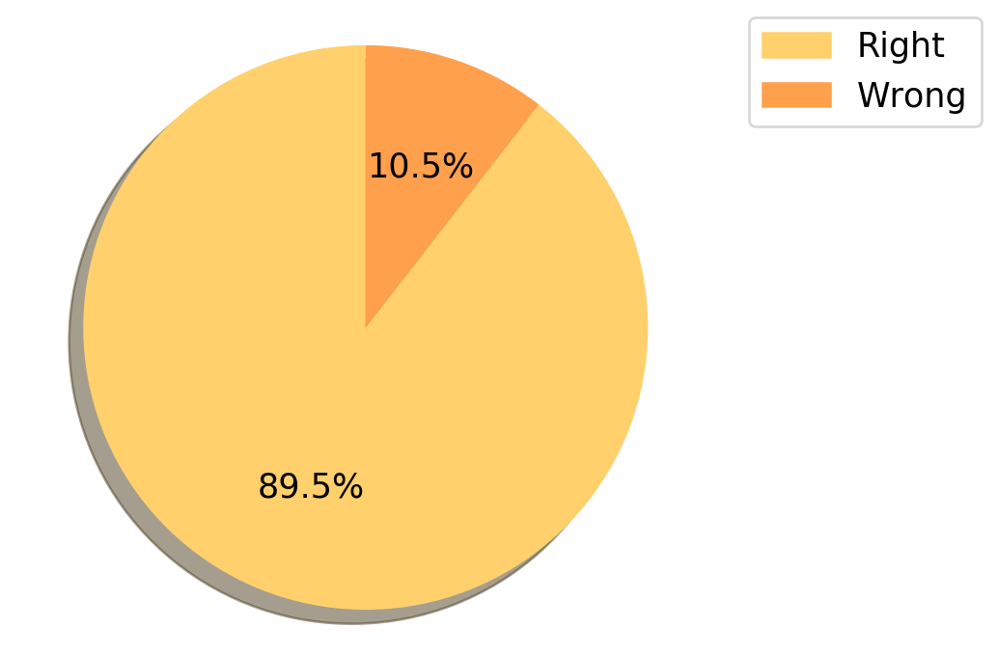

## Identity Consistency and PSS

### Hypothesis:

**H3:** We can use the Repertory Grid to calculate the identity consistency of people to predict ther perceived stress scores

### Methodology:

* Defined the mean variance in the rating of all different circumstances except for “as I would like to be” as identity consistency
* Looked at correlation between identity consistency and PSS
* Did a linear regression for consistency and PSS

### Results:

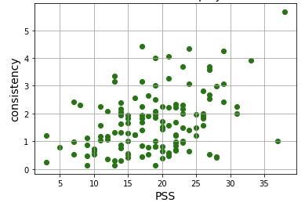

* Identity variance and PSS were found to be moderately positively correlated, r(132) = .38, p<.001, which means the higher the variance in identity (low consistency) the higher the PSS.
* The linear regression had an R2 score of 0.357

## Identity Consistency and PSS

### Hypothesis:

**H4:** Users with higher identity consistency take shorter for the identity prioritisation process

### Methodology:

* Calculated Identity consistency and time for identity part of the questionnaire
* Calculated person correlation coefficient

### Results:

* Identity consistency and time spent on the questionnaire were found to have no correlation.

## Decision Tree Identity

### Hypothesis:

H5: We can predict the PSS with demographics and results from the identity part

### Methodology:

* Used age, number of kids, the importance of each identity construct and the rating of the stressful situations as features
* Used low, medium and high PSS as target
* Created decision tree classifier

### Results:

* Decision tree with 90%/10% split resulted in an accuracy of 0.64

